**Donor module:**

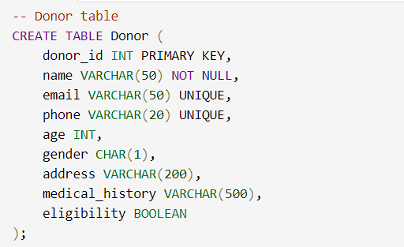

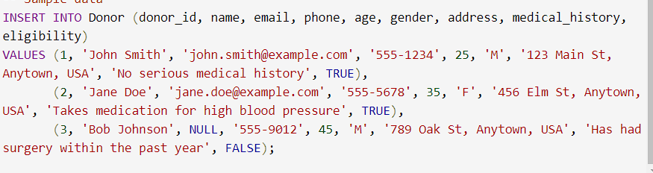

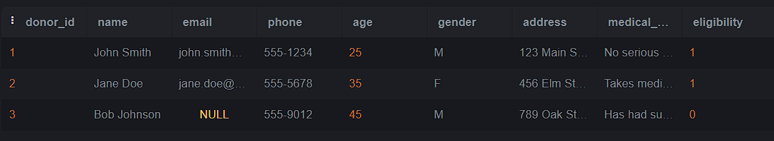

**Blood Inventory Module:**

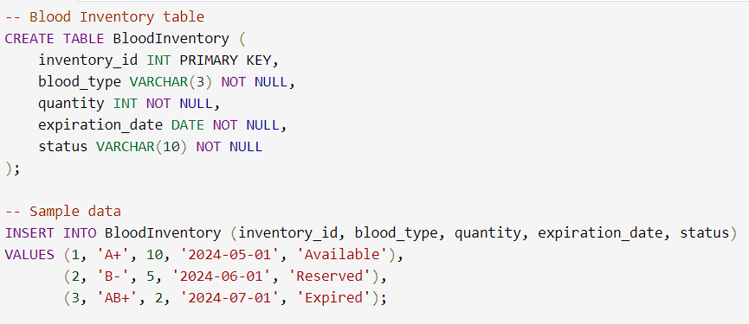

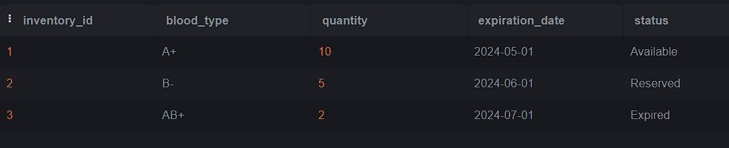

**Blood Donation Module: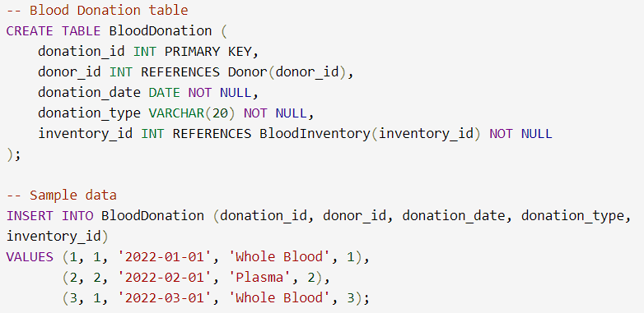e:** 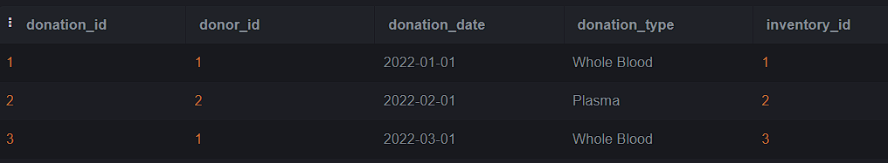

**Blood Request Module:**

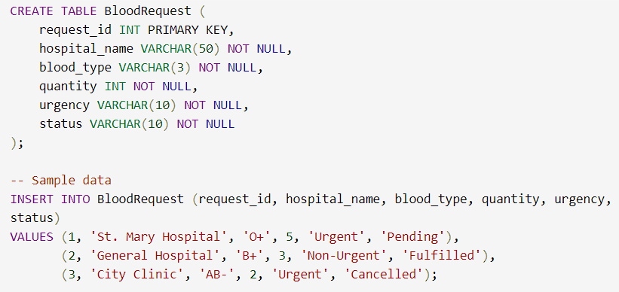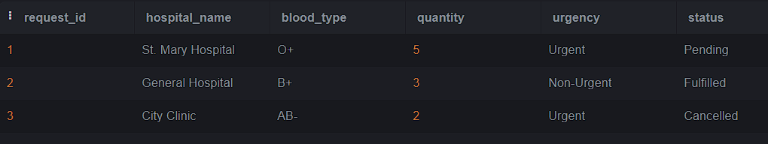

**Reporting Module:**

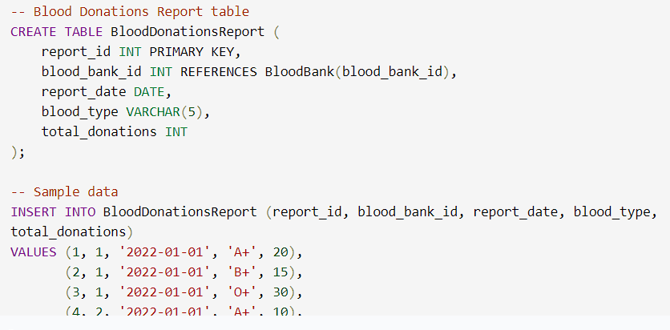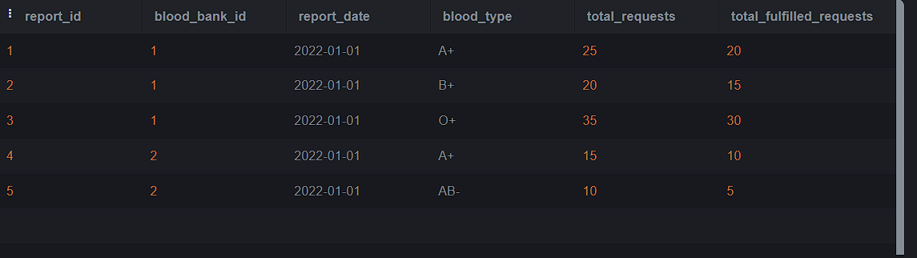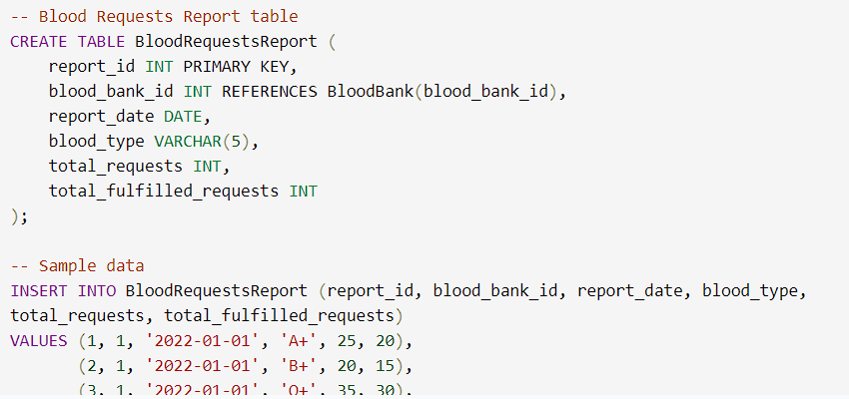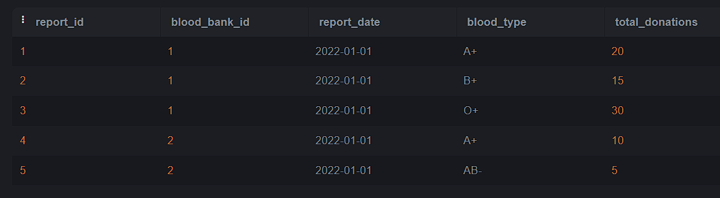

**Administration Module:**

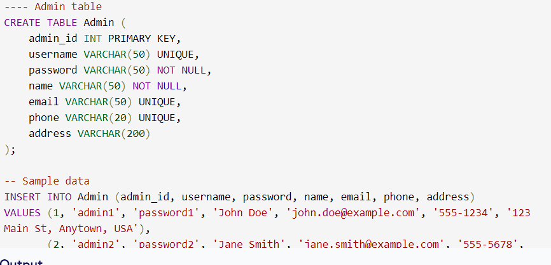

CREATE TABLE Donor (

Donor_ID INT PRIMARY KEY,

Name VARCHAR(255) NOT NULL,

Age INT,

Gender VARCHAR(10),

Blood_Type VARCHAR(5),

Contact_No VARCHAR(20),

Address VARCHAR(255),

Medical_History VARCHAR(255)

);

INSERT INTO Donor VALUES

(1, 'John Doe', 25, 'Male', 'O+', '1234567890', '123 Main St, Anytown, USA', 'None'),

(2, 'Jane Doe', 30, 'Female', 'B+', '9876543210', '456 Elm St, Anytown, USA', 'Asthma'),

(3, 'Bob Smith', 45, 'Male', 'AB-', '5551234567', '789 Oak St, Anytown, USA', 'High Blood Pressure');

SELECT * FROM Donor;

CREATE TABLE Blood_Inventory (

Blood_ID INT PRIMARY KEY,

Blood_Type VARCHAR(5) NOT NULL,

Quantity INT NOT NULL,

Expiration_Date DATE NOT NULL,

Status VARCHAR(10)

);

INSERT INTO Blood_Inventory VALUES

(1, 'O+', 50, '2024-05-01', 'Available'),

(2, 'B+', 20, '2024-06-01', 'Available'),

(3, 'AB-', 10, '2024-05-01', 'Reserved');

SELECT * FROM blood_inventory;

CREATE TABLE Donation (

Donation_ID INT PRIMARY KEY,

Donor_ID INT,

Donation_Date DATE,

Blood_Type VARCHAR(5),

Test_Result VARCHAR(10),

FOREIGN KEY (Donor_ID) REFERENCES Donor(Donor_ID)

);

INSERT INTO Donation VALUES

(1, 1, '2022-04-01', 'O+', 'Negative'),

(2, 2, '2022-05-01', 'B+', 'Positive'),

(3, 1, '2022-05-15', 'O+', 'Negative');

SELECT * FROM Donation;

CREATE TABLE Request (

Request_ID INT PRIMARY KEY,

Hospital_Name VARCHAR(255) NOT NULL,

Request_Date DATE NOT NULL,

Blood_Type VARCHAR(5) NOT NULL,

Quantity INT NOT NULL,

Urgency VARCHAR(10)

);

INSERT INTO Request VALUES

(1, 'St. Mary Hospital', '2022-04-05', 'O+', 5, 'Urgent'),

(2, 'General Hospital', '2022-05-10', 'B+', 10, 'Routine'),

(3, 'Children Hospital', '2022-05-15', 'AB-', 3, 'Urgent');

SELECT * FROM request;

